**Java Application Development**

**10. Supermarket Project**

10.3 Employee Module – Simple [Sprint-1]

10.3.1 Database and Data Preparation

|  |  |
| --- | --- |
| **To be filled by the student** | |
|  |  |
| Reg. No. |  |
| Name |  |
|  |  |
| Assignment Number | 10.3.1 |
| Submission Date |  |

(1) Install MySQL (mysqld.exe [DBMS] & mysql.exe [CLI-DB-Admin Tool])

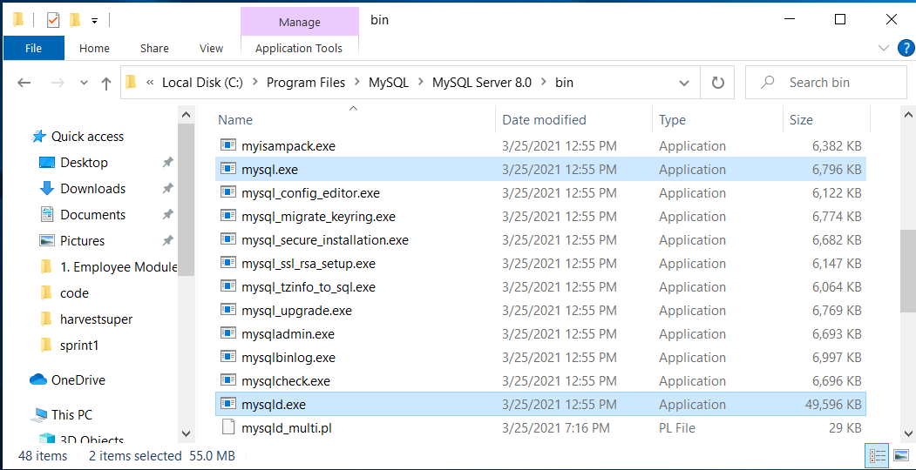

(2) Install MySQL-Workbench [DB-Design & GUI-DB-Admin Tool]

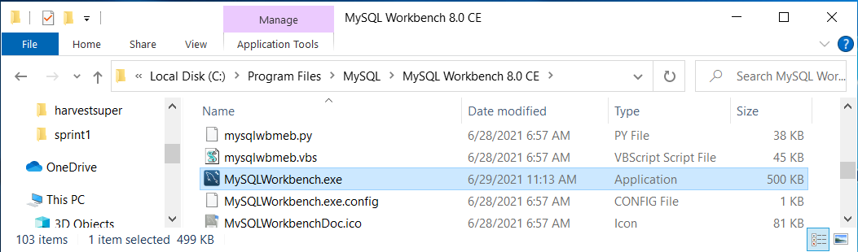

(3) Create a Folder as "harvestsuper" for the Project

(4) Download the ER relevant to Sprint-1 into the above folder

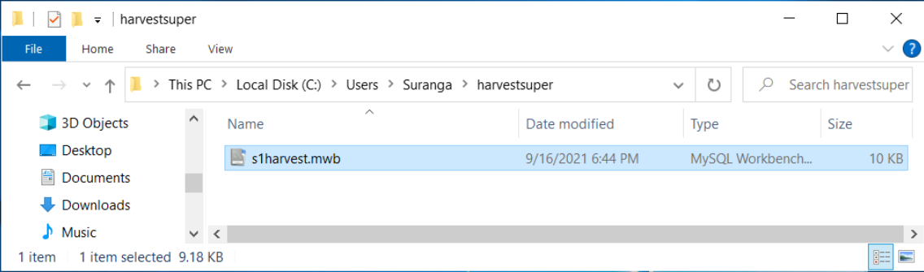

(5)(a) Open with MySQL-Workbench

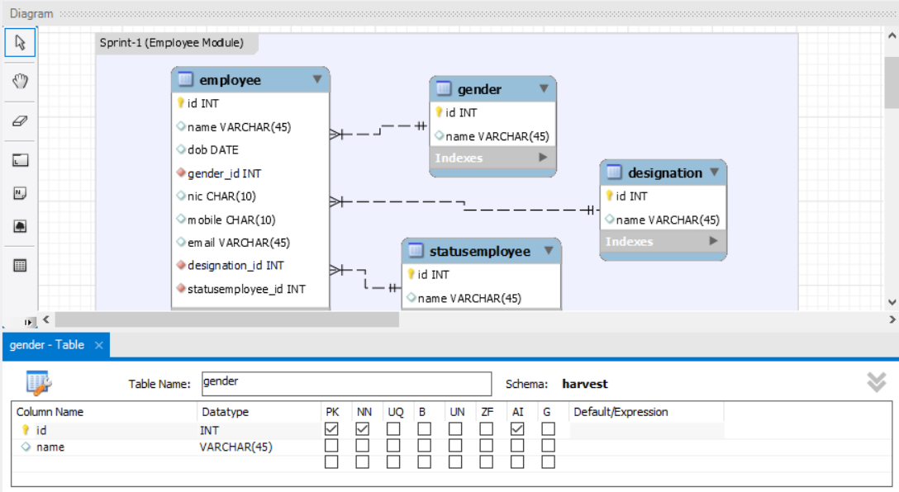

(5)(b) Open with MySQL-Workbench

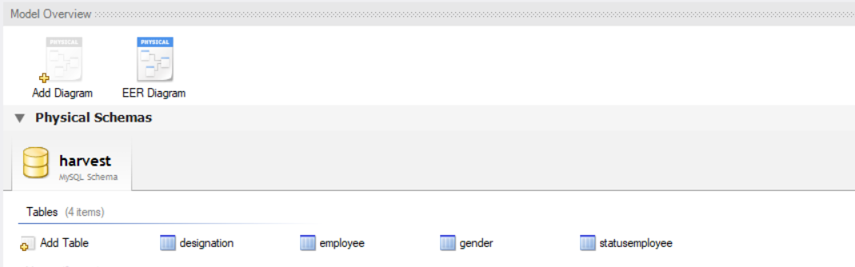

(6) Forward Engineer the ER to create the Database

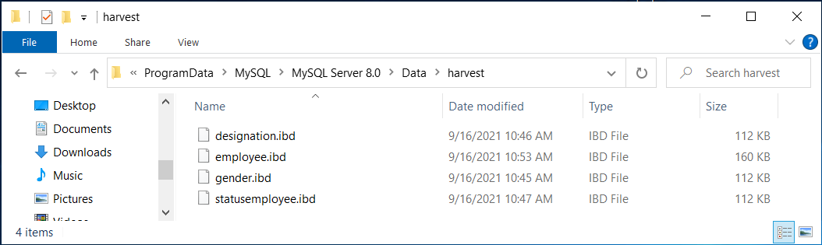

(7) Insert Sample Data into the Tables

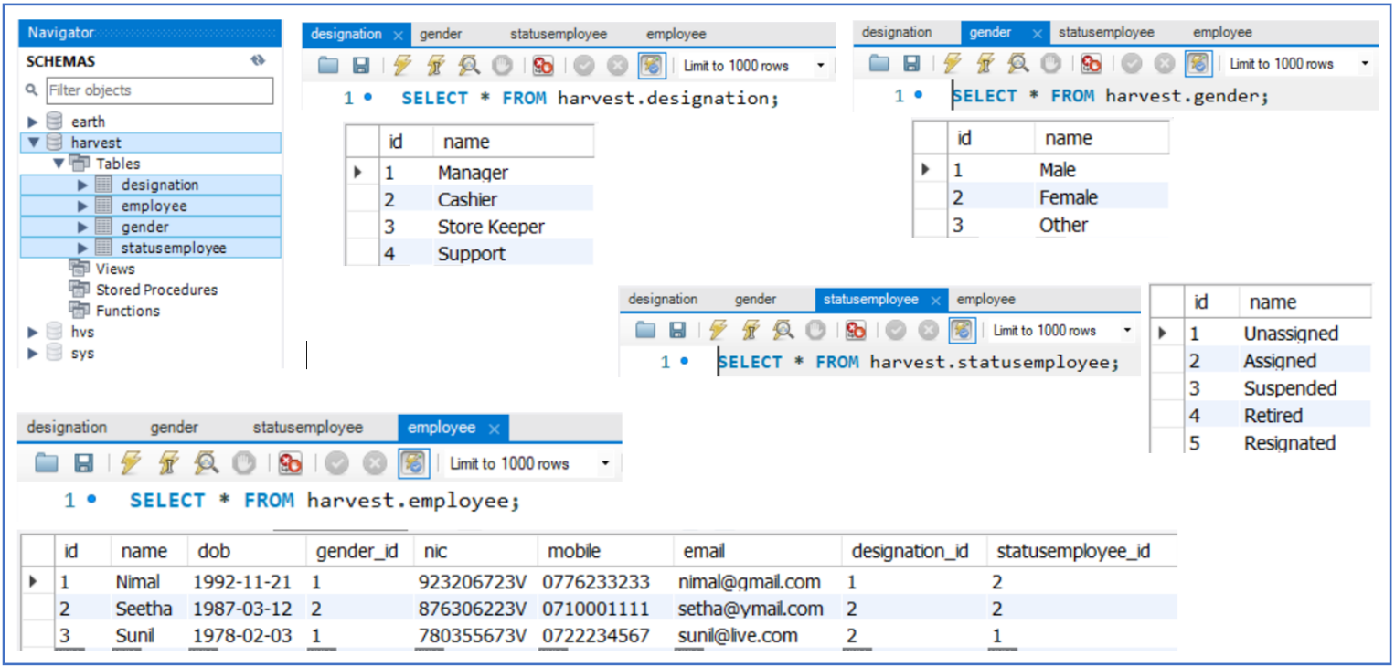

(8) Create User Account as "us2" and give CRUD privileges to "harvest"

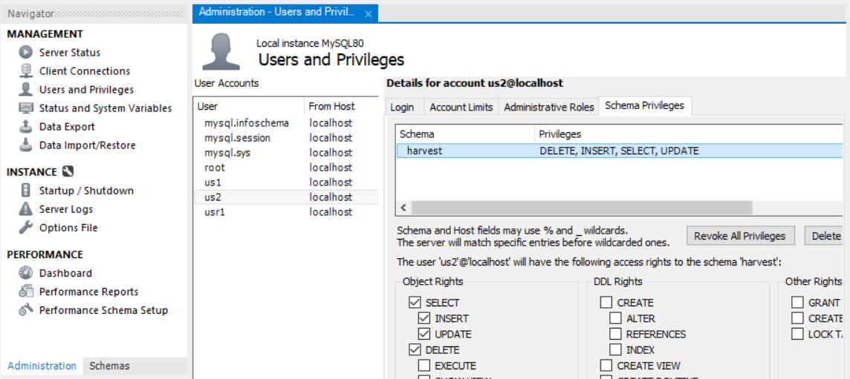

|  |  |
| --- | --- |
| **To be filled by the evaluator** | |
|  |  |
| SIN |  |
| Name |  |
| Evaluation Date |  |
|  |  |
| |  |  |  | | --- | --- | --- | | Step | Rate | Comment | |  |  |  | | 1 |  |  | | 2 |  |  | | 3/4 |  |  | | 5(a) |  |  | | 5(b) |  |  | | 6 |  |  | | 7 |  |  | | 8 |  |  | | |
| Individual Viva | Date : Rate : Comment: |
| Remote Login | Date : Rate : Comment: |
|  |  |
| Final Grade |  |

**Department of Information Technology**

**Earth University College**